LAB Logbook

Lab 1 – Week 1
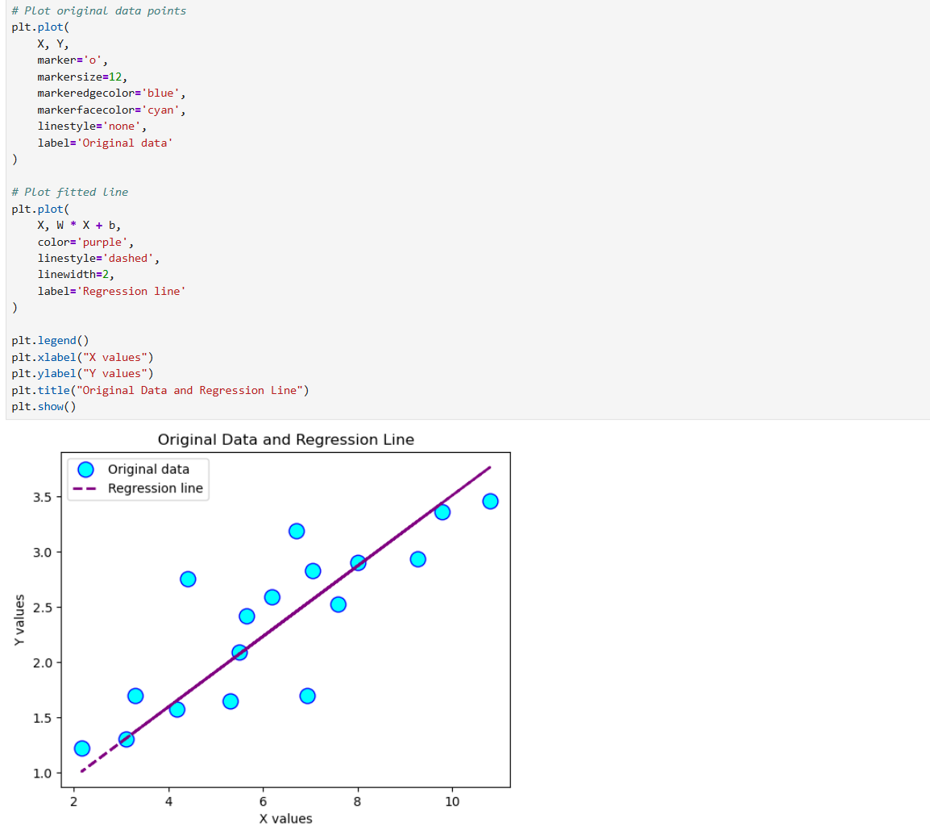

Lab 2
TASK-1
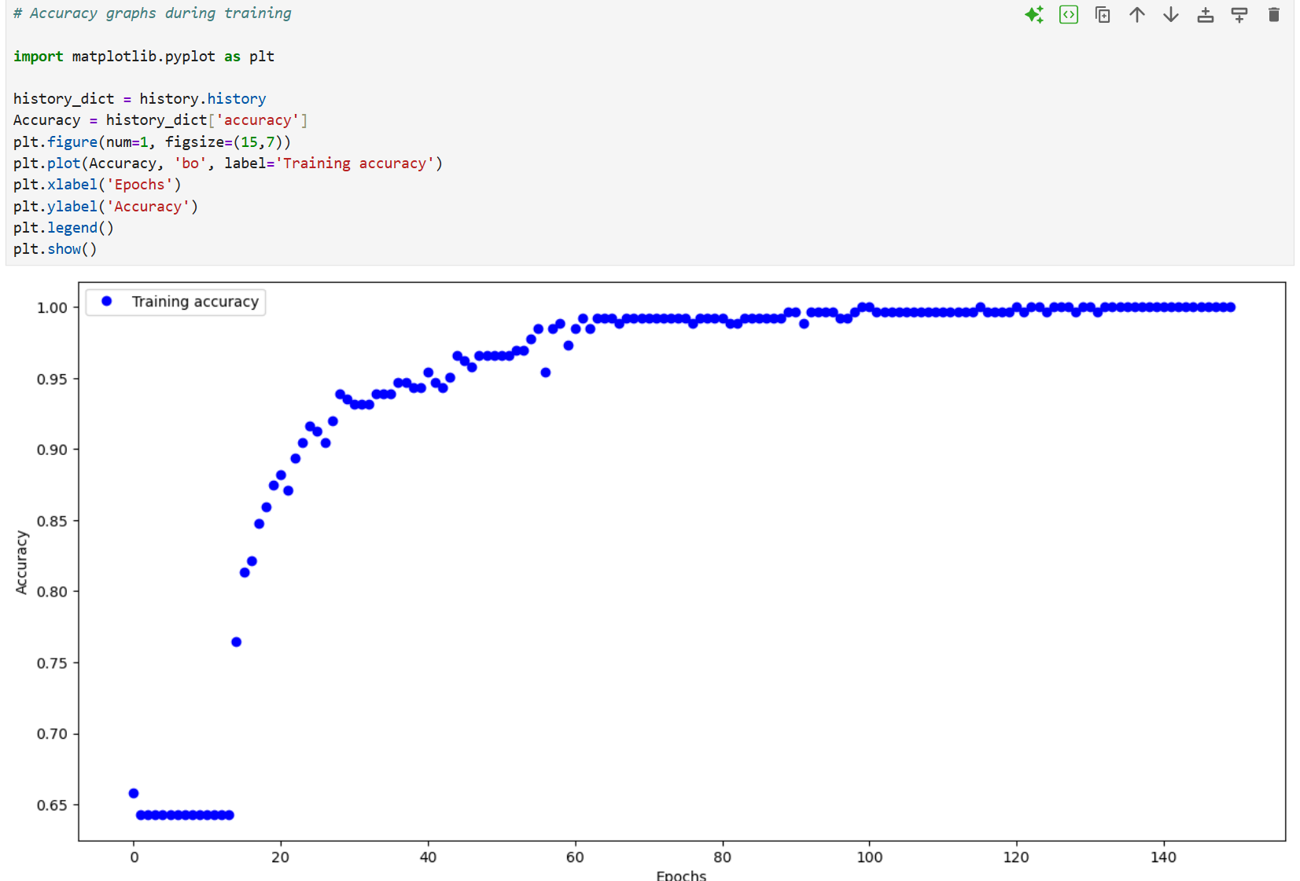
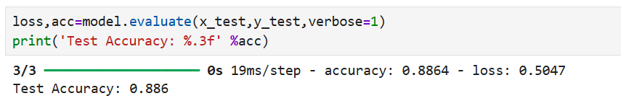

Task-2-
Output O1 = 0.99999
Output O2 =0.99964

Lab 3

Lab 4

Lab 5

Lab 6

Lab 7

Lab 8

Lab 9

Lab 10

Lab 11

Lab 12

